**Tableau Assignment- 3**

**1. Basic Table Calculation:**

**○ Using the "Superstore" dataset, create a table calculation that shows the running**

**total of sales over time. Provide a screenshot of your calculation setup and the**

**resulting visualization.**

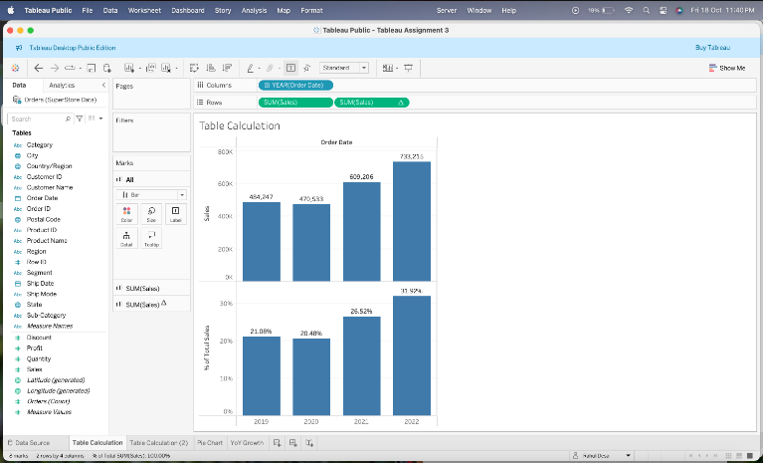

**2. Percentage of Total:**

**○ Create a table calculation that shows the percentage of total sales by category.**

**Provide a screenshot of your calculation setup and the resulting pie chart.**

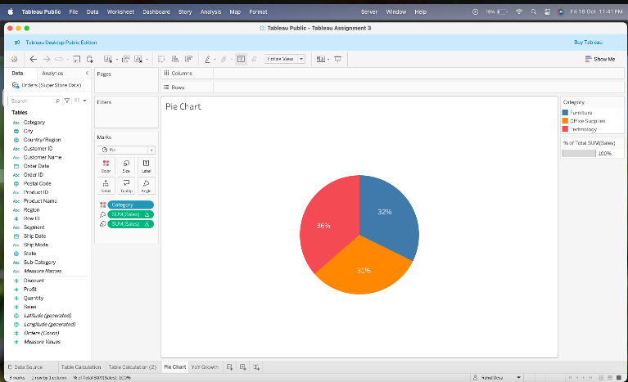

**3. Year-over-Year Growth:**

**○ Calculate the year-over-year growth in sales. Create a line chart that displays this**

**growth. Provide a screenshot of your calculation setup and the resulting**

**visualization.**

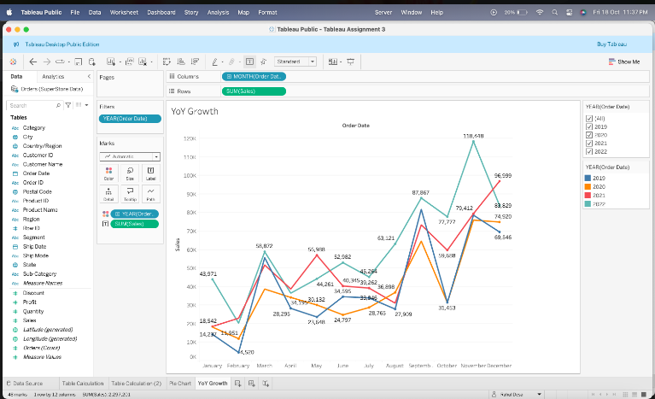

**4. Moving Average:**

**○ Create a moving average calculation to smooth the monthly sales data. Display**

**this on a line chart. Provide a screenshot of your calculation setup and the**

**resulting visualization.**

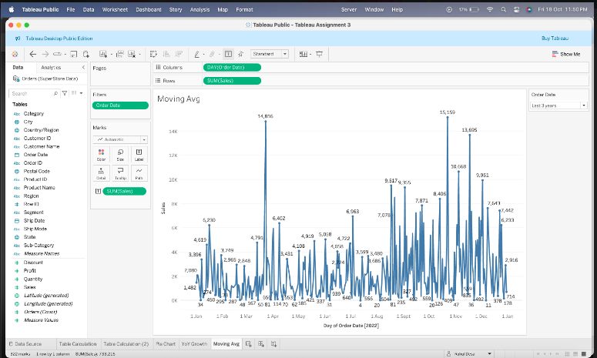

**5. Rank Calculation:**

**○ Rank the sub-categories based on total sales. Create a bar chart that shows the**

**ranked sub-categories. Provide a screenshot of your calculation setup and the**

**resulting visualization.**

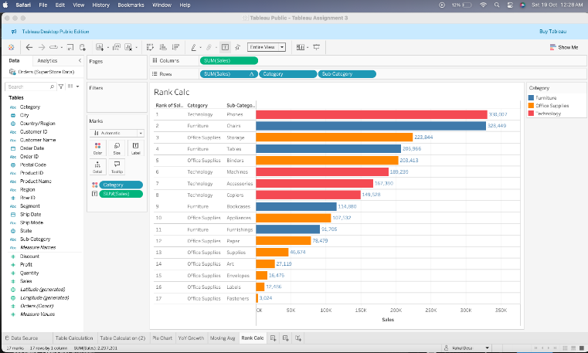

**6. Filter Actions:**

**○ Create a dashboard with a bar chart of sales by category and a line chart of sales**

**over time. Implement a filter action so that selecting a category in the bar chart**

**filters the line chart. Provide a screenshot of your dashboard and filter action**

**setup.**

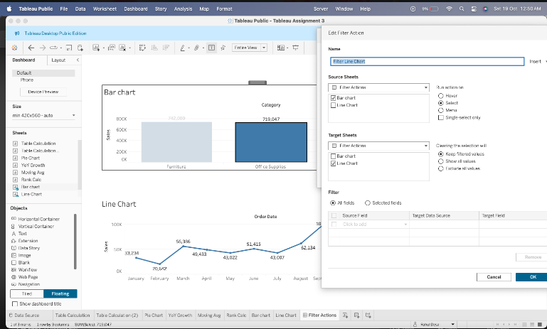

**7. Highlight Actions:**

**○ Add a highlight action to a dashboard containing a scatter plot of sales vs. profit**

**by sub-category and a bar chart of total sales by sub-category. Provide a**

**screenshot of your dashboard and highlight action setup.**

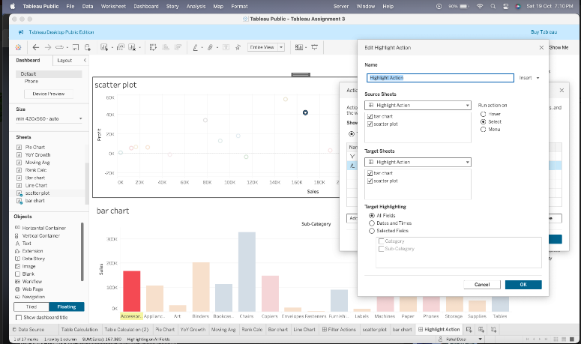

**8. URL Actions:**

**○ Create a dashboard that includes a URL action. When a user clicks on a specific**

**region in a map visualization, they are taken to a webpage with more information**

**about that region. Provide a screenshot of your dashboard and URL action setup.**

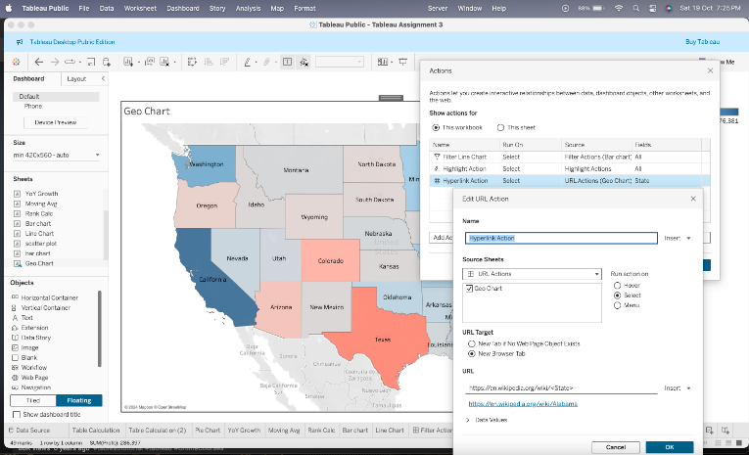

**9. Combined Actions:**

**○ Combine filter, highlight, and URL actions in a single dashboard that includes**

**multiple visualizations (e.g., bar chart, line chart, map). Describe the interactions**

**and provide a screenshot of your combined action setup.**

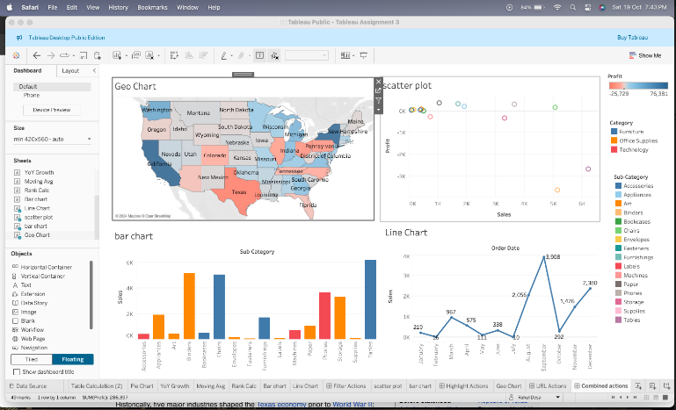

**10. Parameter Actions:**

**○ Create a parameter action that updates a parameter value based on user**

**interaction with a visualization (e.g., selecting a category updates a parameter**

**that controls another chart). Provide a screenshot of your parameter action setup**

**and the resulting visualization.**

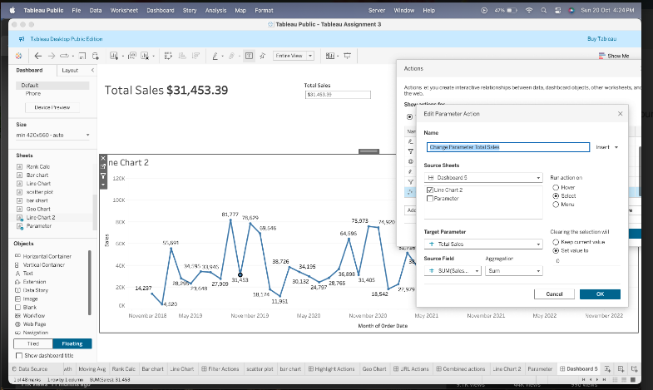

**11. Effective Use of Space:**

**○ Design a dashboard using the "Superstore" dataset that effectively uses space to**

**display a bar chart, line chart, and map. Ensure readability and balance. Provide**

**a screenshot of your dashboard and explain your design choices.**

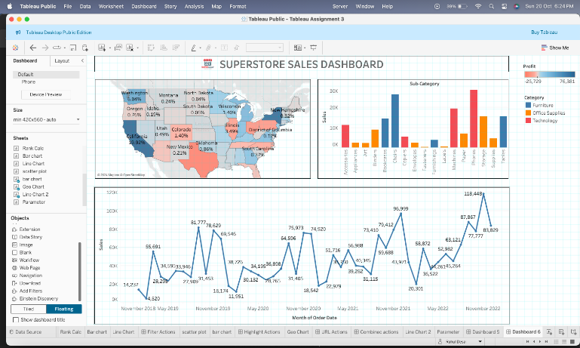

**12. User Experience:**

**○ Create a dashboard that includes interactive elements (e.g., filters, parameters)**

**and ensures a smooth user experience. Provide a screenshot of your dashboard**

**and explain how you optimized user experience.**

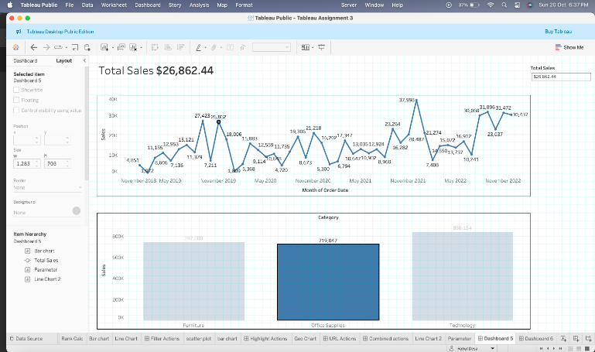

**13. Consistent Formatting:**

**○ Design a dashboard with consistent formatting for colors, fonts, and chart types.**

**Use the "Superstore" dataset to create visualizations for sales, profit, and order**

**quantity. Provide a screenshot of your dashboard and explain your formatting**

**choices.**

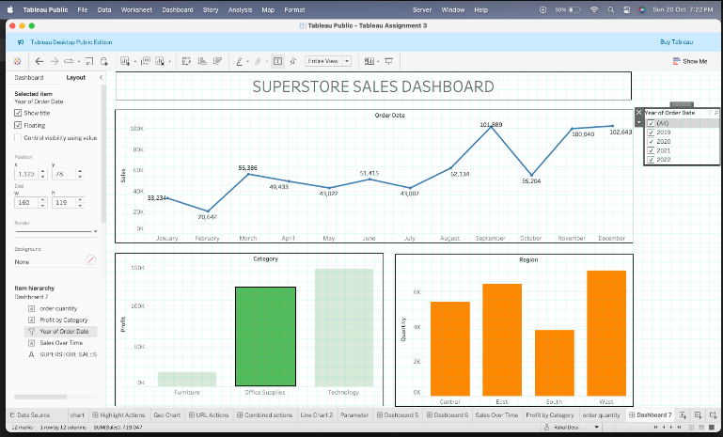

**14. Performance Optimization:**

**○ Create a dashboard that is optimized for performance. Use extracts, minimize the**

**use of complex calculations, and ensure fast loading times. Provide a screenshot**

**of your dashboard and explain your optimization strategies.**

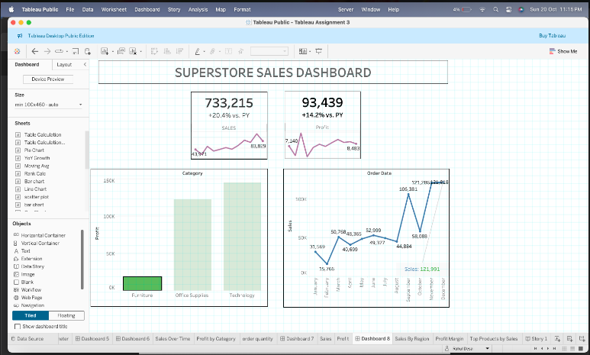

**15. Dashboard Storytelling:**

**○ Design a dashboard that tells a clear story about sales trends and performance**

**over time. Use annotations, interactive elements, and well-chosen visualizations**

**to guide the user through the data. Provide a screenshot of your dashboard and**

**explain how it conveys the intended story.**

